Name : Alveena naz
Registration number = FA25-BSE-010
Lab : 03
Activity 1;
public class FirstJavaJava
{
public static void main(String[] args)
{
double distance = 1.49597E11;
double mass = 1.989E30;

System.out.println("The sun is " + distance + " meters away");
System.out.println("The sun's mass is " + mass + " kg");

}

}

OUTPUT:
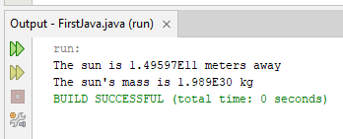

Activity 02:
public class FirstJavaJava
{
public static void main(String[] args)
{
double basePay = 30;
double regularHours = 45;
double overTimePay = 26.5;
double overTimeHours = 15;
double regularWages = basePay * regularHours;
double overTimeWages = overTimePay * overTimeHours;

double totalWages = regularWages + overTimeWages;
System.out.println(" Wages for this week is " + totalWages);

}

}
OUTPUT:
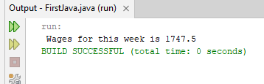

Activity 03;
public class FirstJavaJava
{
public static void main(String[] args)
{
double monthlyPay = 6000;
double contribution = monthlyPay * 0.05;
System.out.println(" 5 percent is $" + contribution + " this month");

contribution = monthlyPay * 0.08;
System.out.println(" 8 percent is $" + contribution + " this month");

contribution = monthlyPay * 0.1;
System.out.println(" 10 percent is $" + contribution + " this month");
}
}
OUTPUT:

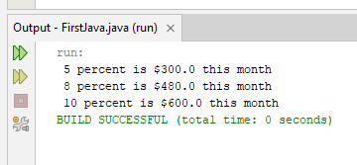

Activity 4;
public class FirstJavaJava
{
public static void main(String[] args)
{
double num1 = 127.899;
double num2 = 3465.148;
double num3 = 2.45;
double num4 = 245.98;
double num5 = 1799.999;

System.out.printf(" %8.2f\n" , num1);
System.out.printf(" %8.2f\n" , num2);
System.out.printf(" %8.2f\n" , num3);
System.out.printf(" %8.2f\n" , num4);
System.out.printf(" %8.2f\n" , num5);
}
}
OUTPUT
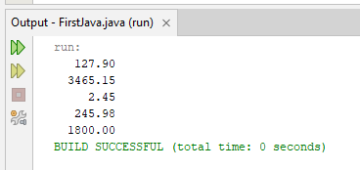

Activity 5:
import java.util.Scanner;
public class FirstJava
{
public static void main(String[] args)
{
Scanner input = new Scanner(System.in);
System.out.print("Enter purchase amount: ");
double purchaseAmount = input.nextDouble();
double tax = purchaseAmount * 0.06;

System.out.println("Sales tax is " + (int)(tax * 100) / 100.0);

}
}
OUTPUT:
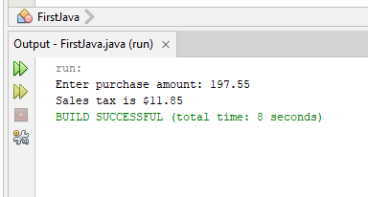

Graded lab task 1:
import java.util.Scanner;
public class FirstJava
{
public static void main(String[] args)
{
Scanner input = new Scanner(System.in);
System.out.print("Enter an amount in decimal numbers: ");
double amount = input.nextDouble();

int cents = (int)(amount * 100);
int dollars = cents / 100;
int remainingCents = cents%100;
int quarters = remainingCents / 25;
remainingCents = remainingCents%25;
int dimes = remainingCents / 10;
remainingCents %= 10;
int nickels = remainingCents / 5;
remainingCents = remainingCents % 5;
int pennies = remainingCents;
System.out.println(" dollars = " + dollars + "\n quarters = " + quarters + " \n dimes = " + dimes + " \n nickels = " + nickels + " \n pennies = " + pennies );

}

}

OUTPUT:
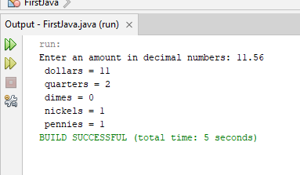

Graded lab Task 2:
import java.util.Scanner;
public class FirstLab
{
public static void main(String[] args)
{
Scanner input = new Scanner (System.in);
System.out.println(" Enter the numbers of students : ");
int N = input.nextInt();
System.out.println(" Enter the numbers of apples :");
int K = input.nextInt();
int studentsApples = K / N;
int remainingApples = K % N;
System.out.println(" Each students gets Apples = " + studentsApples + "\nThe remaining apples are = " + remainingApples);
}
}
Output:
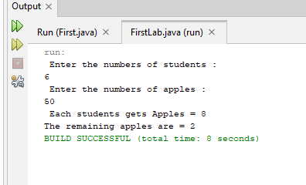

Graded Lab task 3;
import java.util.Scanner;
public class FirstLab
{
public static void main(String[] args)
{
Scanner input = new Scanner (System.in);
System.out.println(" Enter the numbers of students in class a : ");
int a = input.nextInt();
System.out.println(" Enter the numbers of students in class b : ");
int b = input.nextInt();
System.out.println(" Enter the numbers of students in class c : ");
int c = input.nextInt();
int deska = a / 2;
int deskb = b / 2;
int deskc = c / 2;
int totalDesks = deska + deskb + deskc;
totalDesks+=2;

System.out.println("The smallest number of Desks for all of the three classes : " + totalDesks );

}
}

OUTPUT:
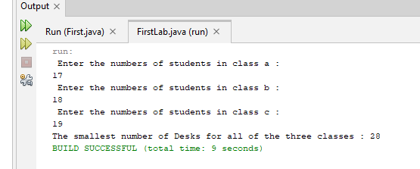
Graded Lab Task 4:
import java.util.Scanner;
public class FirstLab
{
public static void main(String[] args)
{
Scanner input = new Scanner (System.in);
System.out.println(" Enter the value of minutes that is passed since midnight : ");
int min = input.nextInt();
int hours = min / 60;
int minutes = min % 60;
System.out.println( hours + ":" + minutes);

}
}

OUTPUT:
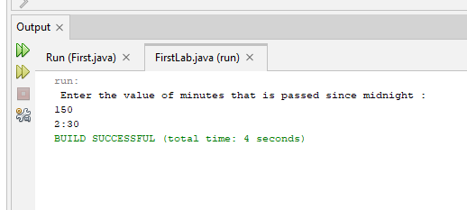
Graded Lab Task 5:
import java.util.Scanner;
public class FirstJava
{
public static void main(String[] args)
{
Scanner input = new Scanner (System.in);
System.out.println("Enter total amount of milk produced in the morning : ");
double amountOfMilk = input.nextDouble();
double cartonCapacity = 3.78;
double costPerLiter = 0.38;
double profitPerCarton = 0.27;
double numberOfCartons = Math.round(amountOfMilk / cartonCapacity);
double costOfMilk = Math.round(amountOfMilk * costPerLiter);

double profitOfMilk = numberOfCartons * profitPerCarton;

System.out.println(" Number of milk cartons needed to hold milk :" + numberOfCartons + " \nThe cost of producing milk : $" + costOfMilk + "\nThe profit for producing milk : $" + profitOfMilk);

}
}

OUTPUT 5:

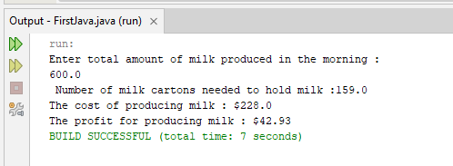

Graded Task 6:
import java.util.Scanner;
public class FirstJava
{
public static void main(String[] args)
{
Scanner input = new Scanner (System.in);
System.out.println(" Ente the value of pay rate for an hour:");
double payRate = input.nextDouble();
System.out.println(" Ente the numbers of hours you worked : ");
double hoursWorked = input.nextDouble();
double grossIncome = payRate * hoursWorked;
double tax = grossIncome * 0.14;
double netIncome = grossIncome - tax;
double clothes = Math.round(netIncome * 0.10);
double supplies = Math.round( netIncome * 0.01);
double remaining = netIncome - (clothes + supplies);
double savingBonds = remaining * 0.25;
double parentsContribution = savingBonds * 0.50;
System.out.println("income before taxes = $" + grossIncome + "\nincome after taxes = " + netIncome + "\nmoney spend on clothes = $" + clothes + " \nmoney spend on school supplies = $" + supplies + "\nmoney spend to buy saving bonds = $" + savingBonds + "\nmoney spend by parents for additional saving bonds = $" + parentsContribution);
}

}

OUTPUT:
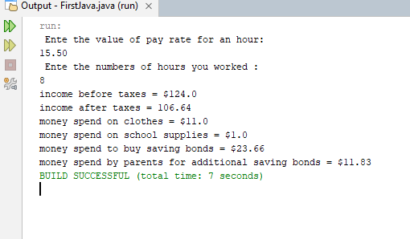
Graded lab Task 7:
import java.util.Scanner;
public class FirstJava
{
public static void main(String[] args)
{
Scanner input = new Scanner (System.in);
int classACost = 20;
int classBCost = 15;
int classCCost = 10;
int classDCost = 5;
System.out.println("number of tickets sold of class A :");
int classATicketsSold = input.nextInt();
System.out.println("number of tickets sold of class B :");
int classBTicketsSold = input.nextInt();
System.out.println("number of tickets sold of class C :");
int classCTicketsSold = input.nextInt();
System.out.println("number of tickets sold of class D :");
int classDTicketsSold = input.nextInt();
int classAIncome = classATicketsSold * 20;
int classBIncome = classBTicketsSold * 15;
int classCIncome = classCTicketsSold * 10;
int classDIncome = classDTicketsSold * 5;

int totalIncome = classAIncome + classBIncome + classCIncome + classDIncome;

System.out.println("Income of class A = $" + classAIncome + "\nIncome of class B = $" + classBIncome + " \nIncome of class C = $" + classCIncome + " \nIncome of class D = $" + classDIncome + "\nTotal income = $" + totalIncome);

}

}

OUTPUT:
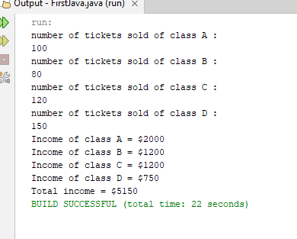

Graded lab task 8:
import java.util.Scanner;
public class FirstJava
{
public static void main(String[] args)
{
Scanner input = new Scanner (System.in);
System.out.println("Enter a number between 0 and 1000 :");
int number = input.nextInt();
int sum = 0;
while(number > 0)
{
int rem = number % 10;
number = number / 10;
sum +=rem;
}
System.out.println(" sum of digits of a number is :" + sum);
}
}
OUTPUT:
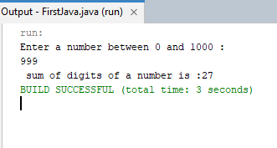
Graded Lab task 9:
import java.util.Scanner;
public class FirstJava
{
public static void main(String[] args)
{
double x = 75.3987;
double y = 982.89764;

System.out.printf("%.2f\n", x);
System.out.printf("%.2f\n", y);
System.out.printf("%.3f\n", x);
System.out.printf("%.3f\n", y);
}

}
OUTPUT:
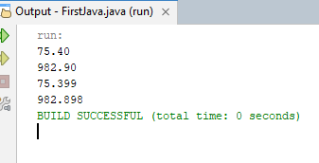

Graded lab task 10:
import java.util.Scanner;
public class FirstJava
{
public static void main(String[] args)
{
int degrees = 30;
double radians = Math.toRadians(degrees);
double sin = Math.sin(radians);
double cos = Math.cos(radians);
double tan = Math.tan(radians);
System.out.printf(" Radian = %.3f Sine = %.3f Cosine = %.3f Tangent = %.3f\n " , radians , sin , cos , tan);

degrees = 60;
radians = Math.toRadians(degrees);
sin = Math.sin(radians);
cos = Math.cos(radians);
tan = Math.tan(radians);
System.out.printf("Radian = %.3f Sine = %.3f Cosine = %.3f Tangent = %.3f\n " , radians , sin , cos , tan);

}

}

OUTPUT:
